**CENWP-OD-D 6/27/2023**

**MEMORANDUM FOR THE RECORD**

**SUBJECT: 23TDA04 MFR Gatewell Mortalities**

On 6/25/23 during a gatewell inspection, mortalities were observed in the following intake gatewells; 7 morts in unit 6, 16 morts in unit 7, 8 morts in unit 15, 31 morts in unit 16. All these units were not running at the time of inspection. Many of the mortalities appear old, expected some of the previously observed fish in these gatewells.

1. Species –Appear to be subyearling chinook
2. Origin –NA
3. Length –NA
4. Marks and tags –NA
5. Marks and Injuries found on carcass –Not visible from distance
6. Cause and Time of Death –unknown
7. Future and Preventative Measures –These areas normally accumulate small numbers of juveniles during passage season, despite no diversion screens. Orifices associated with most of these units have been closed permanently per FPOM agreement in the mid 2000s. 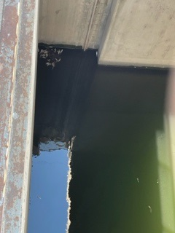

Sincerely,

TDA Project Fisheries